Health, Safety & Environment Committee

Subject: University Fire Officer’s Report February 2011

1. Fire Incidents

There have been 1 fire incidents in the current reporting period:

Localized Fire Incident Rutherford Block 15th October 2010

Timeline

21:01 Bold fire alarm signal received in Security control from Village, Security Officers dispatched, building fully evacuated.

21:05 Telephone call received from Sub-warden, fire confirmed (laptop students bedroom)

21:05 Telephone call to emergency services

21:10 Fire & Rescue Service arrived

21:50 Incident stood down, occupants allowed to re-enter the building

In Summary

A laptop (Compaq) burst into flames in a student’s bedroom. A manual call point in the block was activated by one of the students and all occupants evacuated the building. The duty sub-warden upon arrival confirmed that the laptop (LT) was on fire and quickly placed a fire blanket over the LT and immediately contacted the security gatehouse requesting for the attendance of the Fire & Rescue Service. Security staff also responded and met the duty sub-warden at the entrance to the building to assist. On arrival the Fire & Rescue Service (F&RS) entered the block and removed the LT and ventilated the room/building to clear the smoke. Students were eventually, after approximately 40 minutes, when the smoke had dissipated, allowed back into the building.
The F&RS stood down at 21:50.

Students and staff (sub-warden & Security) are to be complimented in responding rapidly and appropriately to an emergency situation and in particular the prompt actions of the Sub-warden (Lyndsey Bakewell) in containing the fire and preventing it from intensifying.

This incident highlights the importance of staff receiving training which enables them to respond quickly, access the situation and where safe to do so use the appropriate fire fighting equipment to extinguish or suppress the fire.

This fire was successfully managed thus limiting the damage to the building and its contents.

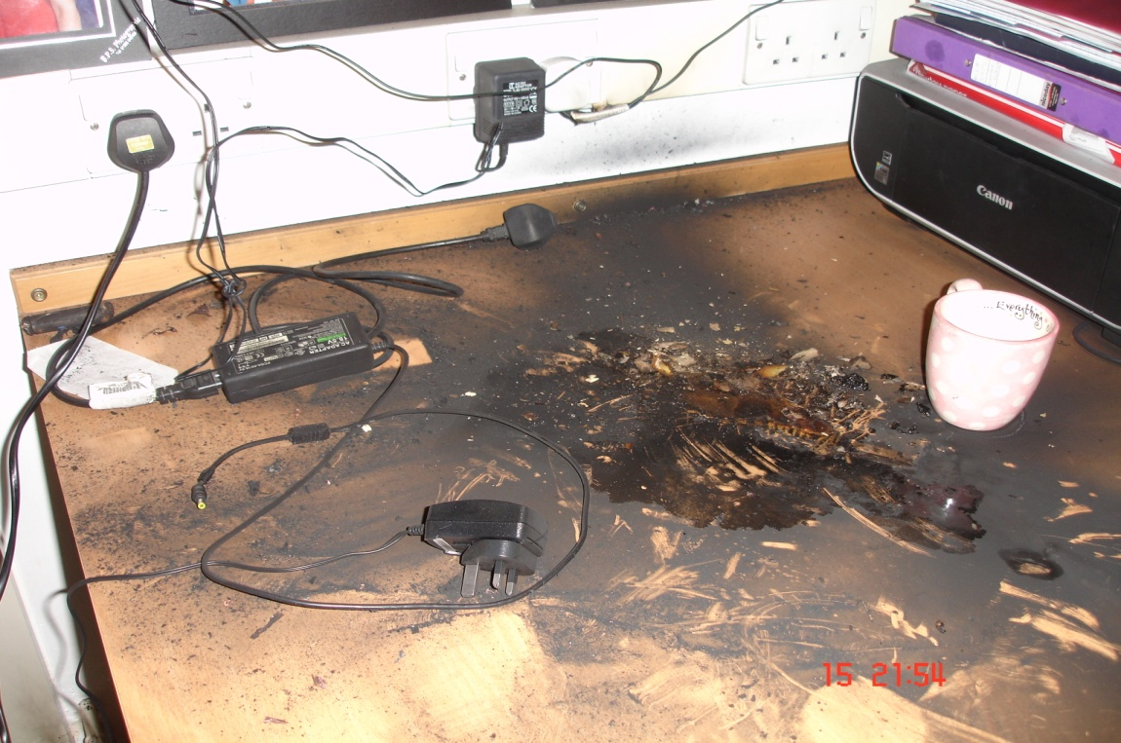

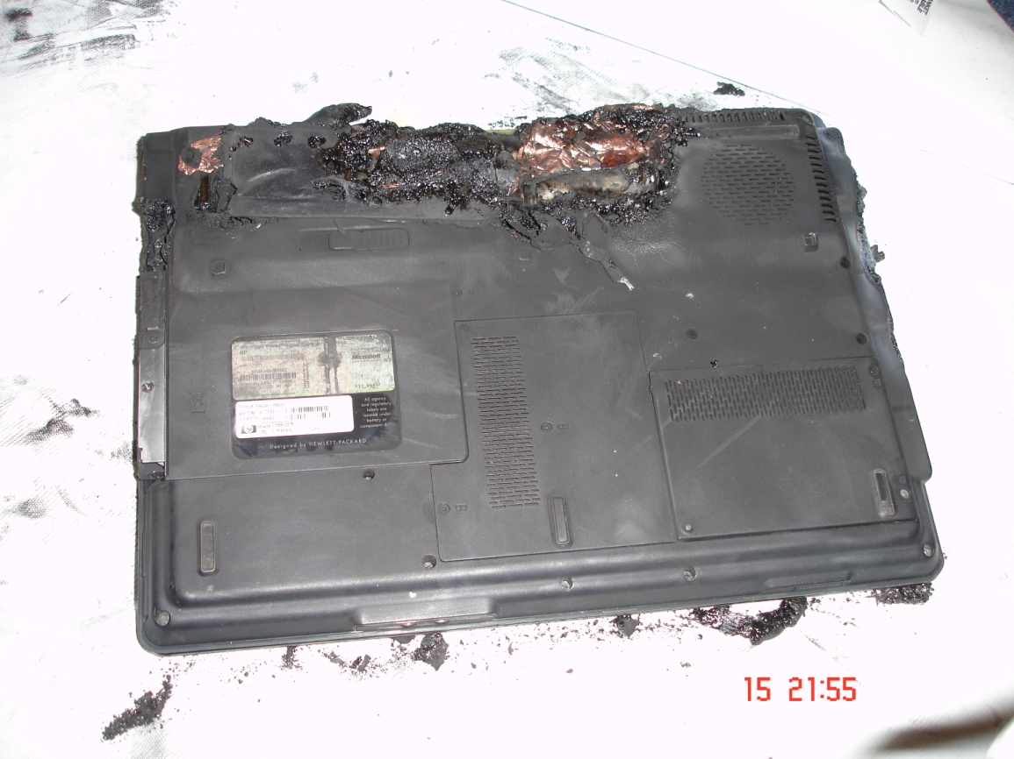

2. Controlled Fire Evacuations Tests on University Buildings (conducted Nov-10)

Overall the annual controlled fire evacuations across campus were very good especially as the tests occurred during the cold weather conditions. The majority of all occupants in the building at the time of the test evacuated, however there were a few buildings where a small number of staff or students were slow in evacuating and these individuals slightly ran over the acceptable time for a safe evacuation of the building by 1 – 2 minutes.

All persons assembled at the designated assembly points were reminded to treat all fire alarm signals as a genuine fire emergency, evacuate the building immediately and use the nearest available exit. Staff/lectures were further reminded of their responsibility for the safety of their students and to ensure they make them selves’ aware of alternative means of escape, the fire action emergency procedures and the location of the fire assembly point. This information is displayed in all lecture theatres / pool rooms.

All Fire Marshals that were in the buildings at the time of the controlled evacuation performed their duties well which incorporated them sweeping their designated areas of the building reporting to the fire alarm panel where they were asked to identify the location of the fire activation.

Issues witnessed

Occupants questioned the fire alarm

Occupants taking considerable time gathering personal belongings before evacuating

Occupants exited the building and went elsewhere rather than reporting to the assembly point

Occupants congregated at the entrance to the building rather than assembling at the designated assembly point

Persons attempted to enter the building whilst the fire alarm was still sounding

Fire doors left wedged open

Recommendations

To prevent delays in evacuating University buildings it is imperative that both staff and students:

- Respond immediately when the fire alarm is sounded
- Exit the building promptly by the nearest available fire exits
- Once outside the building proceed towards the designated fire assembly point allocated to the building
- Wait at the fire assembly point until instruction is given by the fire marshal or security officers to re-enter

Lecturers are reminded to:

- Ensure they understand the university fire action procedures’ (fire action procedures and floor plans showing the location of the fire assembly points are placed in all lecture rooms)
- Ensure they know the location of the fire assembly point assigned to the building they are lecturing in (signage showing the location of the assembly point in relation to the building has been placed in all lecture rooms)
- Know the whereabouts of all available exits
3. USHA Fire Statistics January 2010 to Dec 2010

Please see a copy of Loughborough University fire statistics sent to USHA
*Unfortunately USHA don’t provide a table to compare Loughborough against other participating Universities at the present time.

Accommodation buildings All other buildings
No. of kitchen fires | 0
Total no. of fires (incl. kitchen fires) | 1 | Total no. of fires (incl. kitchen fires) | 6
No. of fires (internal or external) that did not result in fire alarm activation | 0 | No. of fires (internal or external) that did not result in fire alarm activation | 0
No. injuries as a result of fire | 0 | No. injuries as a result of fire | 0
No. of malicious alarms | 38 | No. of malicious alarms | 4
Other false alarms | 362 | Other false alarms | 136
Total number of alarm activations | 401 | Total number of alarm activations | 146
No. times FB attended | 1 | No. times FB attended | 5

Total No of study bedrooms owned or managed by the University | 5068
Approximate No. of AFDs, if known | ??

Building and cause for the attendance of the Fire Rescue Service

Accommodation buildings All other buildings
Rutherford Block 16 (laptop fire) | Holywell Pk Chemtec building (false alarm)
 | S building (insulation material on fire)
 | Stewart Miller (fire on motor in test cell)
 | Schofield (burnt out fuse on lighting)
 | Chemistry (smoke in switch room)

Fire Statistics Loughborough University 2009
Accommodation All other buildings
Total number of alarm activations | 483 | Total number of alarm activations | 113
No. times FB attended | 10 | No. times FB attended | 2

3. Fire Alarm Activations and Fire Service call-outs.

In the last 4 month period the Fire Service have been called to 4 activations 2 of which involved an actual fire (see table below)

 | Oct 10 | Nov 10 | Dec 10 | Jan 11 | Total
Number of Activations | 82 Residential  3 Dining Halls  18 Academic | 57 Residential  4 Dining Halls  15 Academic | 23 Residential  1 Dining Halls  7 Academic | 18 Residential  2 Dining Halls  9 Academic | 180  10  49
Activations involving Fire Service | Rutherford  Schofield | Chemistry |  |  | 3
Genuine Fires | Rutherford 16 |  |  |  | 1

Academic Buildings:

Burleigh Court 1 | Chemistry 3 | Clyde Williams 1
Edward Herbert Building 2 | Haslegrave 1 | Holywell Park 12
Imago Office 1 | James France 5 | John Cooper 1
LUSAD (Fine Arts) 1 | Martin Hall 1 | Rutland Hall (old) 1
S Building 5 | Schofield 1 | Seb Co 1
Sir David Davies 2 | Sir Richard Morris 8 | Stewart Mason 1
Swimming Pool 1

Dining Halls:

Cayley/R-ford D/Hall 2 | Faraday/Royce D/Hall 2 | DavidCollett D/Hall 4
Elvyn Richards D/Hall 2 | William Morris D/Hall 0

Halls of Residence (University Managed):

Butler Court 11 | Cayley 11 | David Collett 18 | Falk / Egg 17
Faraday 26 | Royce 21 | Rutherford 14 | Telford 16
Towers 0 | University Lodge 1 | UPP Blocks 32 | Village Court 10
Whitworth 3 | 200 Ashby Rd 0

Halls of Residence (Not managed by the University) Unite:

Harry French 35 | William Morris 15 | Holt 12

Note
20 activations at Harry French had no visible cause/reason into way they should activate

The Major Causes of Fire Alarm Activations in LU Halls of Residence:

- 53 Unattended cooking in self catering kitchens
- 57 Steam from showers in en-suite bedrooms and aerosol sprays
- 14 Faulty sensors or fire alarm panels
- 15 Unknown causes
- 5 Other (water contamination in detector head, lighting strike, power outage etc.)
- 23 Malicious call point activations or tampering/removing of detector heads
- 8 Accidental activation of call point
- 4 Smoking incident (including Candles & incense sticks)
- 1 Contractors (dust or fumes from paint)

Cooking Related Incidents In LU Halls Of Residence:

Butler Court 7 | Cayley 4 | David Collett 2
Falkner / Eggington 7 | Faraday 8 | Royce 7
Rutherford 3 | Telford 5 | Towers 2
UPP 7 | Whitworth 1 | University Lodge 0

(All above information gathered from period 1/10/10 –31/1/11) R M Harrison –Health, Safety & Environment Office

